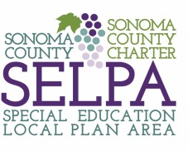

Sonoma County SELPA CAC Agenda for January 22nd 6:30-7:30 (This meeting is in person).
Location: Sonoma County Office of Education

Opening | - Welcome Everyone
Purpose & Agreements | - We will be respectful, listen, and assume positive intent.
Agenda Items | - Welcome/Call to order  - Approval of the agenda  - Executive Director, Elizabeth Engelken  - Public Comment  - Presentation, Larkin O’Leary, Common Ground Society-Advocating for a Culture of Belonging
Follow Up Meetings | - March 11th, Inclusion Panel Location TBD
Closure | Questions?

